How to Request and Install Certificate on IIS Server

Installing a Server Certificate
To enable a secure connection over HTTPS, it is important to first install the server certificate before configuring StoreFront.
When using more than one StoreFront servers in your environment, make sure you have a DNS Host(A) record created pointing to the StoreFront load balancer address. It’s important to use that name for the server certificate.

- Open the Internet Information Services (IIS) Manager and open Server Certificates
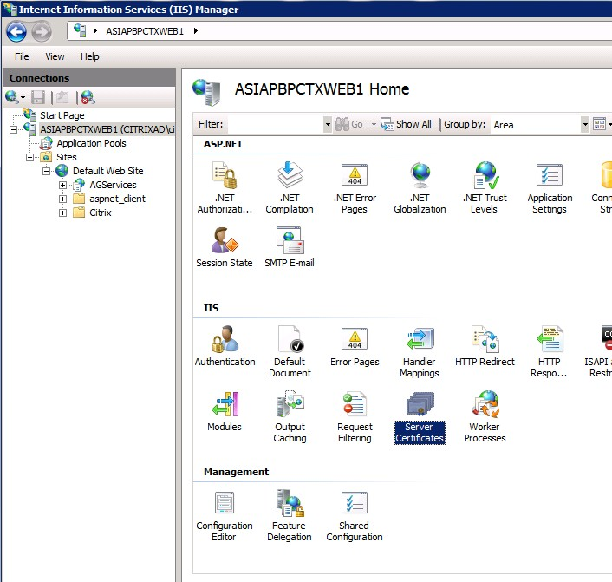

- On the right side of the window click Create Certificate Request
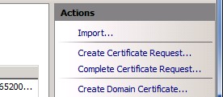

- Fill in the requested information.
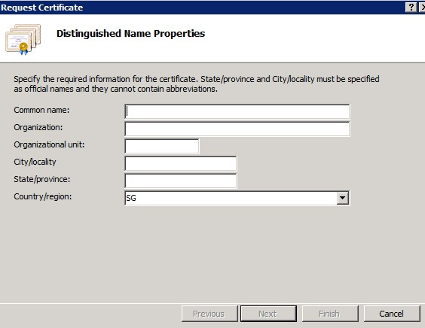
Country = US
State = Oklahoma
City/Locality = Oklahoma City
Organization = SEAGATE TECHNOLOGY LLC
Organizational Unit = IT
Common name = sgmxxxxxx.sing.seagate.com (Your URL / server FQDN)

- Select Microsoft RSA SChannel Cryptographic Provider and a 2048 bit length.
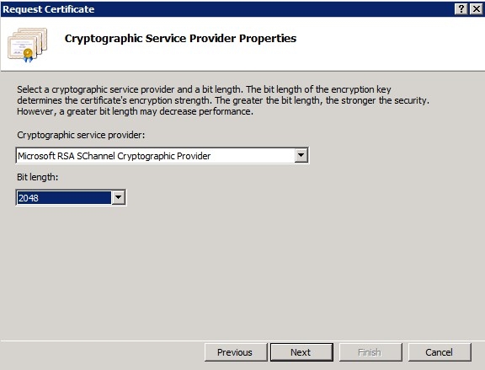

- Save the request to a .CSR file and click Finish
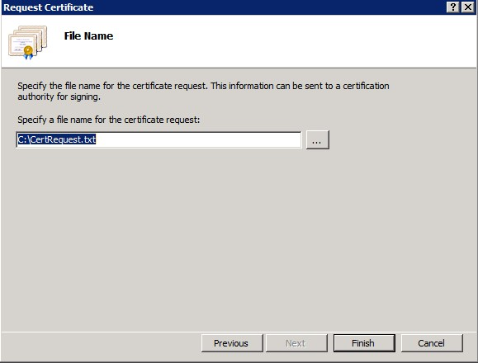

Submit the Text file to SSL Admin for the Certificate creation

- Go to SNOW

- Click on All Application
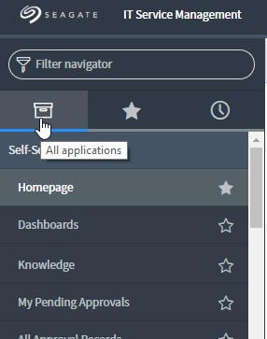

- At the Search box, type service catalog
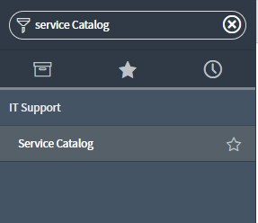

- Click on Service Catalog
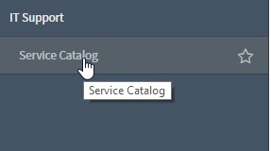

- At Data Center Boxes, click on View All Item
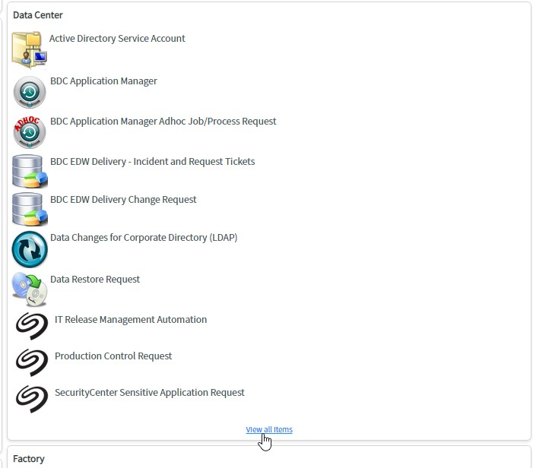

- Scroll down and click on SSL Certificate Request
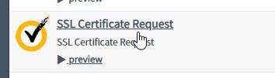

- Enter Below information
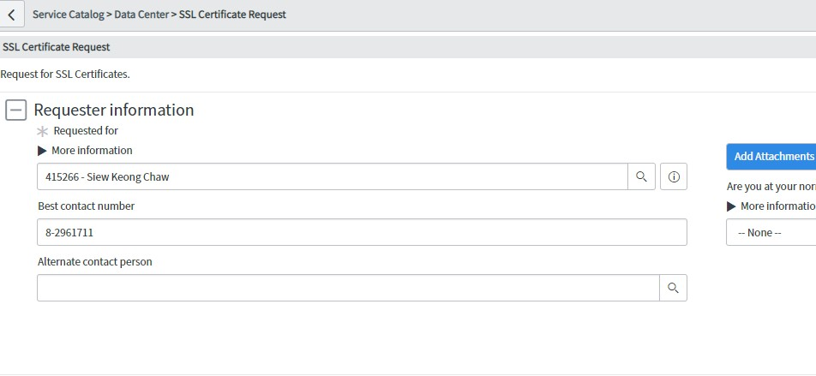

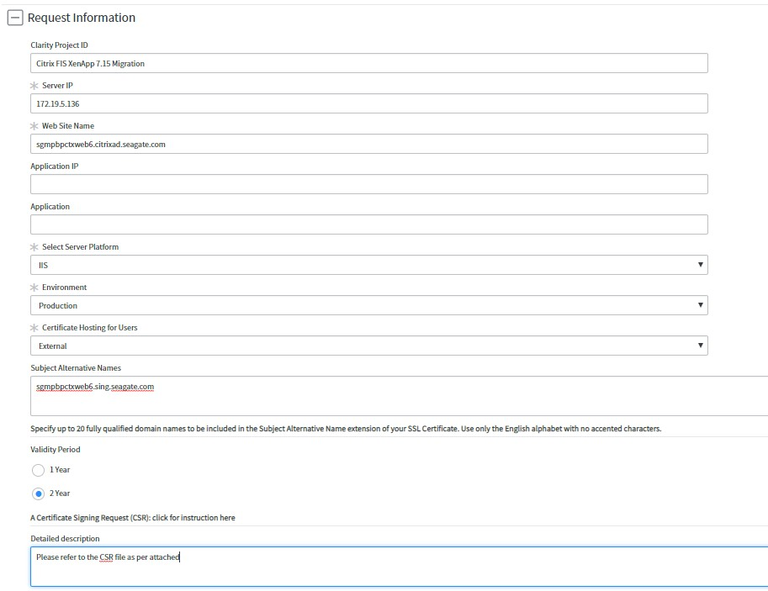
*You can put more like your server FQDN into alternate name
*If your application server in internal , hosting location = Internal
*If your application server in external , hosting location = External

- Attached the CSR file to the SNOW Ticket
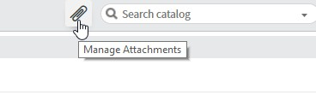
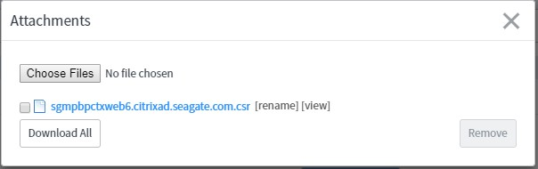

- Click Submit button to submit the request

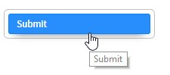

Install Certificate on Server

15. With the newly created Certificate file, Go back to the Internet Information Services (IIS) Manager and click Complete Certificate Request


- p7B cert = complete package consists of all the authentication detail,serve External purpose
- Cer cert = extract package consists of only cert detail ,server Internal purpose

- Browse to the certification file, enter a Friendly name, and select Personal as certificate store. Click OK
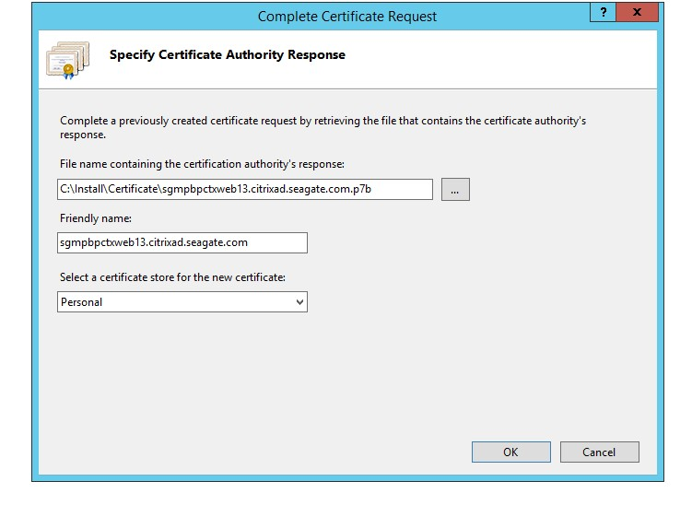
*Friendly name = your storefront web server FQDN
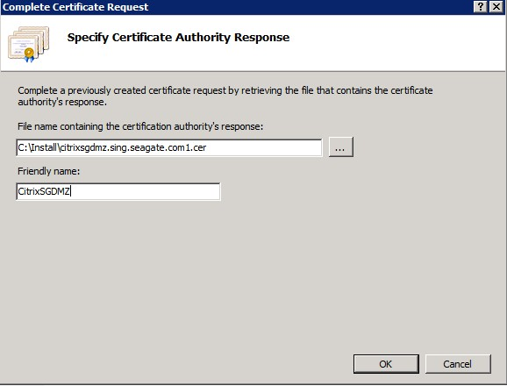

- You should see the certificate successfully install now
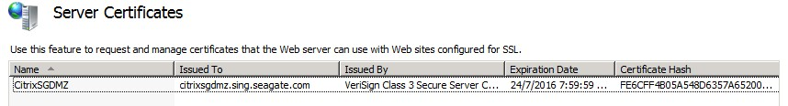

- On the left side of the window, select Default Web Site, on the right side, click Bindings
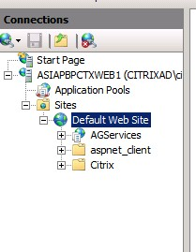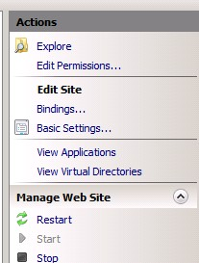

- Click Add
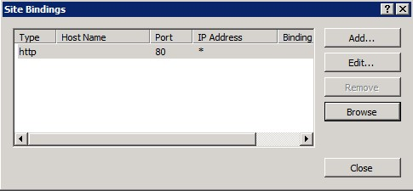

- Select HTTPS as Type and select the StoreFront SSL certificate. Click OK
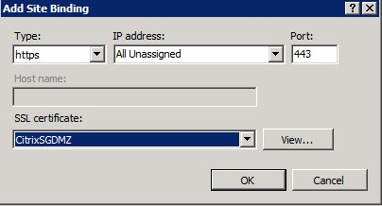

- Click Close
